Blue e+ dynamic cooling units from Rittal
Rittal and Eplan at the SPS 2024
12 to 14 November in Nuremberg
Halle 3C, Booth 321
Rittal cooling units are now seaworthy
Herborn, 2024-11-13
Rittal has further improved its Blue e+ series cooling units to deal with the dynamic loads experienced on the high seas. For the first time, the manufacturer now includes DNV-tested cooling units for maritime applications in its product portfolio under the name Blue e+ dynamic. In addition to the usual EMC compatibility testing for ships, the units’ vibration resistance and safe operation when tilted were also tested. Testing in accordance with the DNV CG 0339 (Class A) standard ensures that energy-efficient appliances cool safely and reliably, even when subjected to high dynamic loads.

Not only wave movements but – above all – vibrations from the ship’s engine cause severe damage to systems and components. Cooling compressors and other heavy components installed in cooling devices are subject to violent vibrations; for example, after a short time, refrigerant lines break and suspended objects are destroyed. The reason: Cooling units are generally not designed for dynamic applications but only for static ones. Compressors traditionally mounted with vibration dampeners to avoid disturbing sensitive equipment like spindles on machine tools in industrial operations may achieve precisely the opposite effect at sea and literally “swing about” and cause many other problems.

That is why Rittal has adapted its Blue e+ series cooling units for maritime applications and made them suitable for use on the high seas. The devices were tested at Phoenix Testlab GmbH in Blomberg and DNV-certified. This also makes them interesting for dynamic applications on land – for example, use in crane systems or airport baggage handling systems.

Numerous DNV tests
A sine sweep test, in which a defined frequency spectrum was traversed, was first performed to test the vibration resistance. A broadband noise test over the entire frequency range then followed. The test piece was vibrated for 2.5 hours in each spatial axis, for a total of 7.5 hours. After the vibration test, the test pieces were placed in the climate chamber, where they were subjected to several temperature cycles, sometimes at high humidity. The inclination, in other words, the ship’s movement, was then simulated on another test bed. The final stage comprised EMC measurements, including interference emission and immunity tests.

Devices in the output classes 1.0 and 1.6 kW and 2.0 and 2.6 kW were tested. The DNV-tested devices will go into series production as “Blue e+ dynamic” in early 2025. The cooling units have a very high energy efficiency with a Seasonal Energy Efficiency Ratio (SEER) of >6.2.

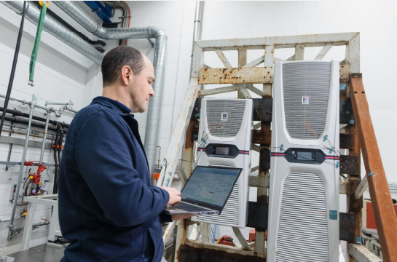
Caption
For the first time, Rittal now includes DNV-tested cooling units for maritime applications in its product portfolio under the name Blue e+ dynamic. In addition to the usual EMC compatibility testing for ships, the units’ vibration resistance and safe operation when tilted were also tested.

May be reproduced free of charge. Please name Rittal GmbH & Co. KG as the source.
Rittal

Rittal is a leading global supplier of enclosure systems, automation and infrastructure with its industrial, IT, energy and power, cooling and service units. Rittal products and solutions are used in over 90% of global industries – standardised, customised, and always of the very best quality.
Our approach and methodology: With their combined hardware and software expertise, Rittal, Rittal Software Systems (Eplan and Cideon) and Rittal Automation Systems (RAS, Ehrt, Alfra) optimize, digitize and automate processes along the entire customer value chain, including the IT infrastructure – from panel building and switchgear manufacturing to mechanical engineering, factory operators and the energy sector.
Our delivery promise: Rittal standard products are delivered in Germany within 24 hours, and within 48 hours throughout Europe.
Customer focus
Improving efficiency and increasing productivity through automation and digitalisation is one of the biggest challenges for our customers. This requires in-depth knowledge and expertise, the combination of hardware and software, and cross-sector networking. We are convinced that creating and connecting data rooms is crucial to the success of industrial transformation. And that is exactly our speciality and field of competence.
Eplan and Rittal are driving the development of the digital automation twin, making data accessible and useable in operations as well. Cideon is improving data consistency in the digital product twin context with its CAD/CAM, PDM/PLM and product configuration expertise.
Sustainability
Environmental and climate protection, social commitment and ethical corporate management are a given for Rittal. We take our responsibility for a sustainable future seriously. Our approach to resource management and conservation involves continuous improvement of our own production processes and ensuring that our products have the lowest possible Product Carbon Footprint. Our solutions support our customers in achieving their own climate targets.
Family business and global player
Founded in 1961, Rittal is the largest company in the owner-operated Friedhelm Loh Group. The group operates worldwide, with 12 production sites and 95 international subsidiaries. It has 12,100 employees and posted revenues of 3 billion euros in fiscal 2023. In 2023, the Friedhelm Loh Group was presented with the “Best Place to Learn” and “Employer of the Future” awards. In 2024, Rittal was awarded the Top 100 Seal as one of Germany’s most innovative medium-sized companies for the third time in a row.
For more information, visit www.rittal.com and www.friedhelm-loh-group.com.

Corporate Communications
Dr. Carola Hilbrand Rittal GmbH & Co. KG
Corporate & Brand Communications Auf dem Stützelberg
Tel.: 02772/505-2527 35745 Herborn
hilbrand.c@rittal.de www.rittal.com


Follow us:

